## SPECIFICATION REPORT

### FOLDER NEST SYSTEM

**TABLE OF CONTENT**

SPECIFICATION REPORT 2

**Folder Nest (A Document Management System)** 2

**Overview** 2

**Authentication and Role-Based Access** 2

**User Capabilities** 2

**Admin Capabilities** 3

**Security and Efficiency** 3

**Conclusion** 3

**Folder Nest (A Document Management System)**

**Overview**

Folder Nest is a Document Management System (DMS) designed to streamline the management, storage, and retrieval of digital documents. It provides robust functionalities for both regular users and administrators, ensuring efficient and secure handling of files and folders.

**Authentication and Role-Based Access**

Folder Nest uses email-based authentication to verify users. This ensures that only authorized personnel can access the system. The system supports two primary roles.

1. Admin
2. User

**User Capabilities**

Regular users have access to a set of functionalities tailored to facilitate document management.

Upload Files. Users can upload various types of files to the system. This ensures that all documents are centralized and easily accessible.

CRUD Operations on Folders. Users can create, read, update, and delete folders. This allows them to organize their documents efficiently, creating a structured hierarchy that suits their workflow.

CRUD Operations on Files. Similar to folder management, users can perform CRUD operations on individual files. This includes editing file metadata, moving files between folders, and deleting unnecessary files.

Step1. Login page for both roles (Users / Admins)

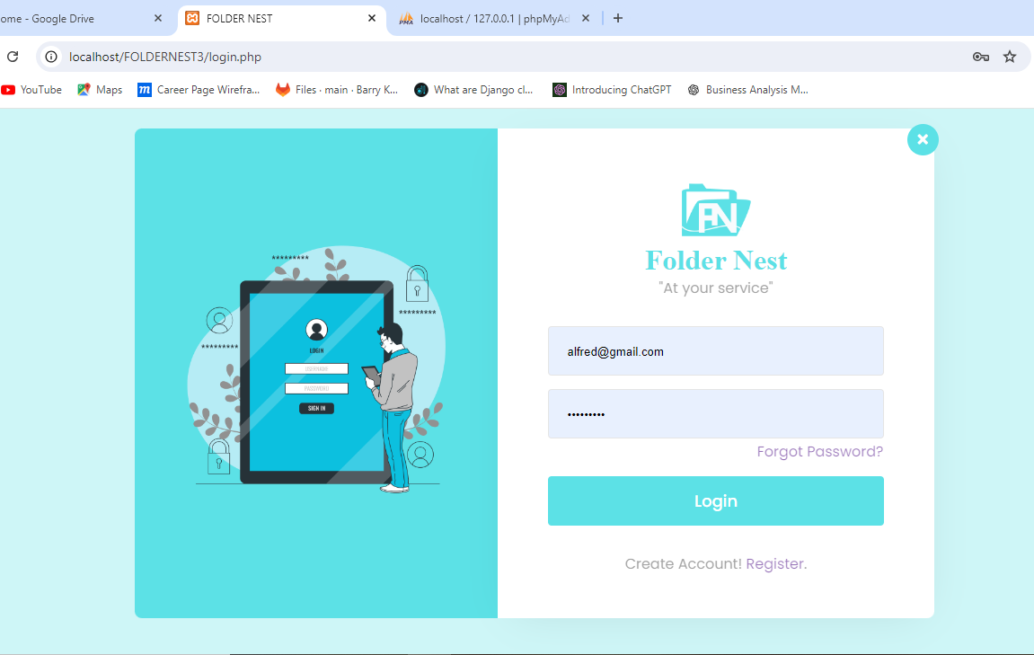

Step 2. sign up page

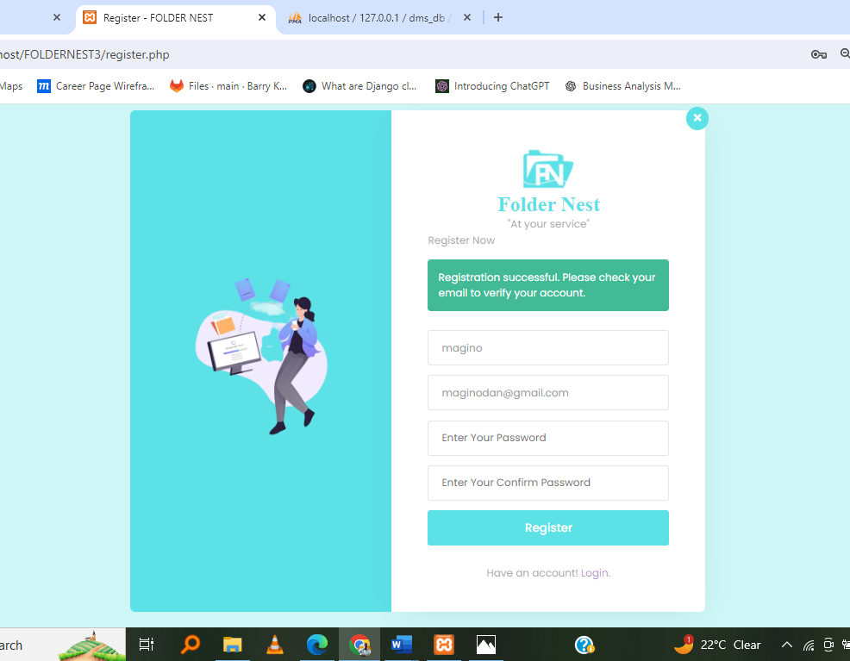

Step 3. Verify account after registering

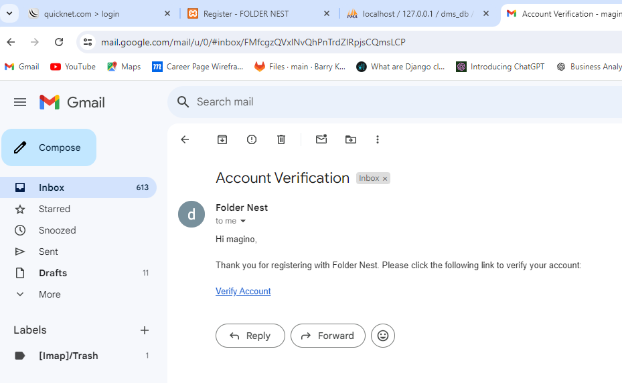

Step 3. Home page for users

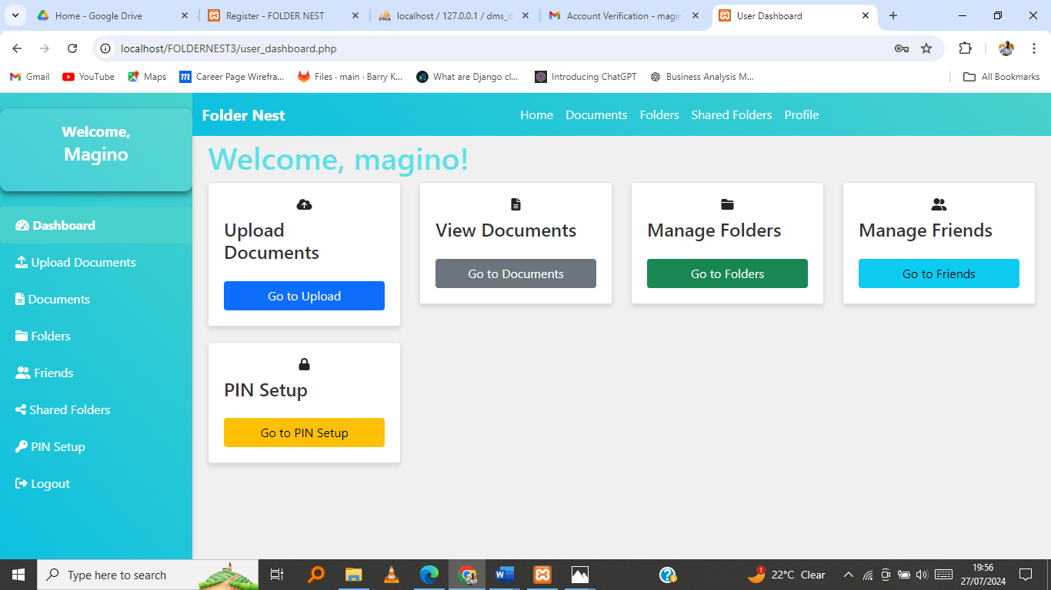

Step 4. Upload page

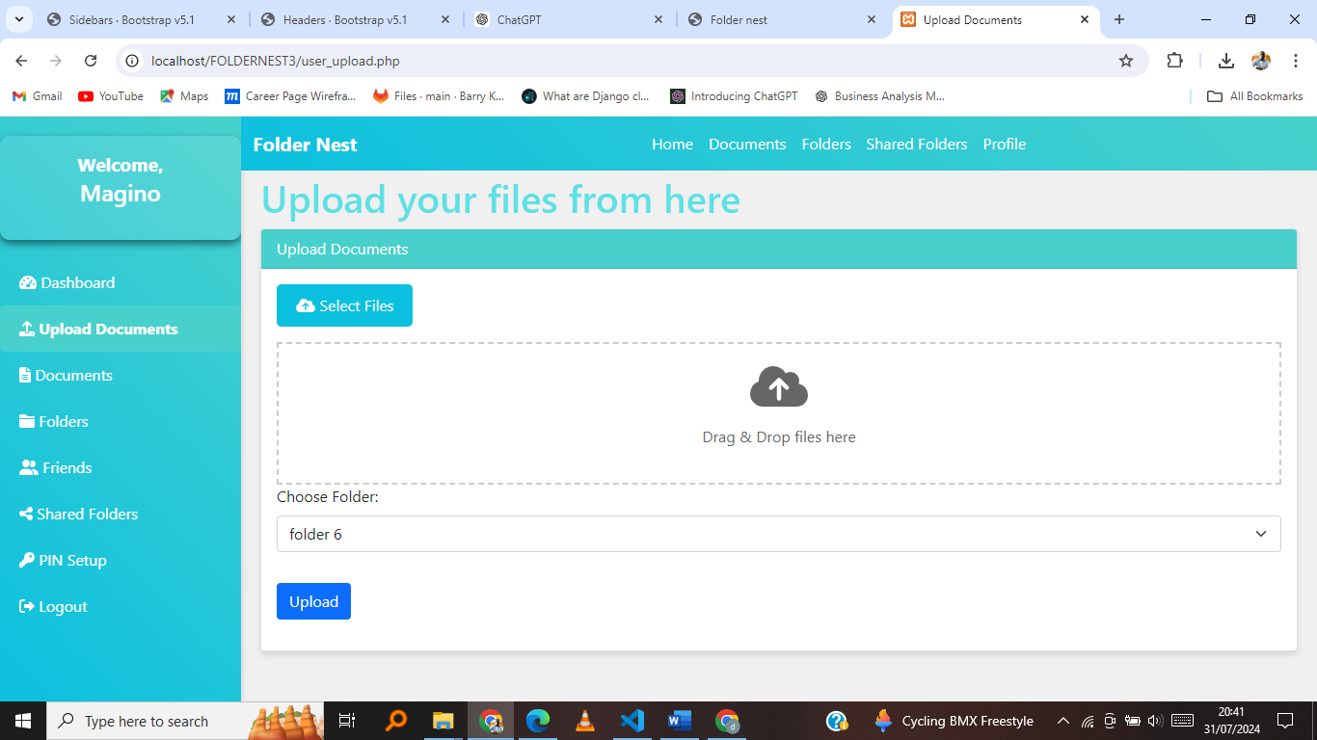

Step 5. Documents page with folders

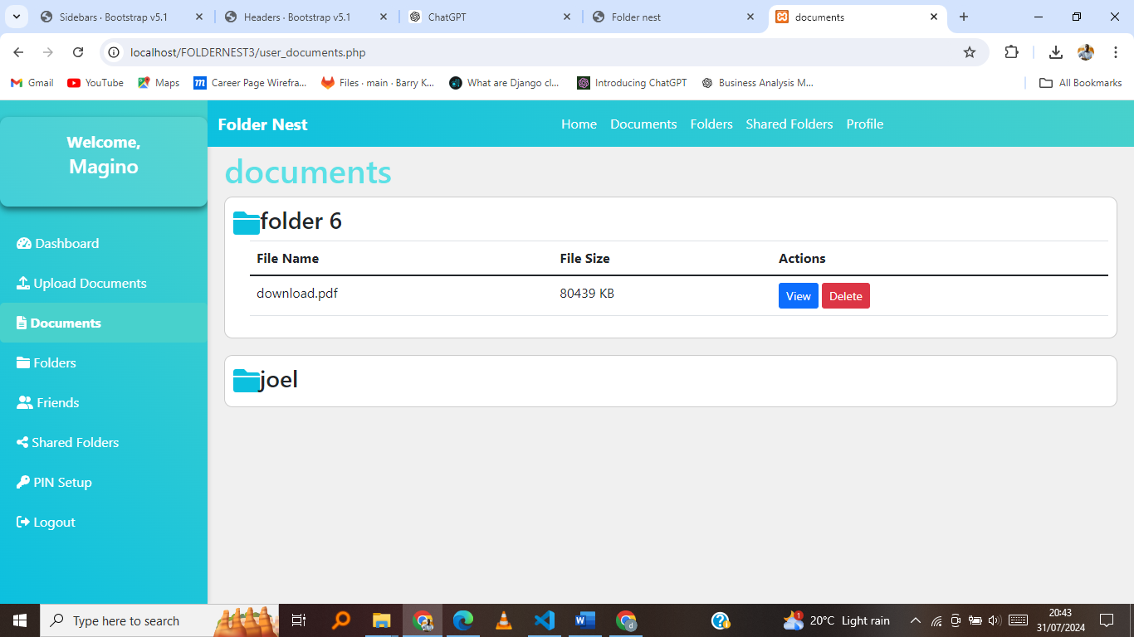

Step 5. Create Folders page

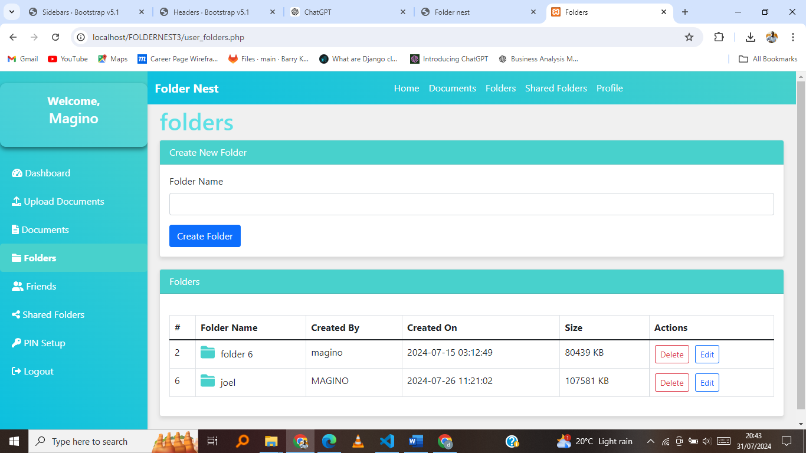

**Admin Capabilities**

Administrators have enhanced privileges, allowing them to manage the overall system and its users.

User Management. Admins can create new users, assign roles, and manage existing users. Includes resetting passwords, updating user information, and deactivating accounts as necessary.

User Content Management. Admins have the ability to oversee and manage the content uploaded by users.

Step 6. This is the Admin page after signing in

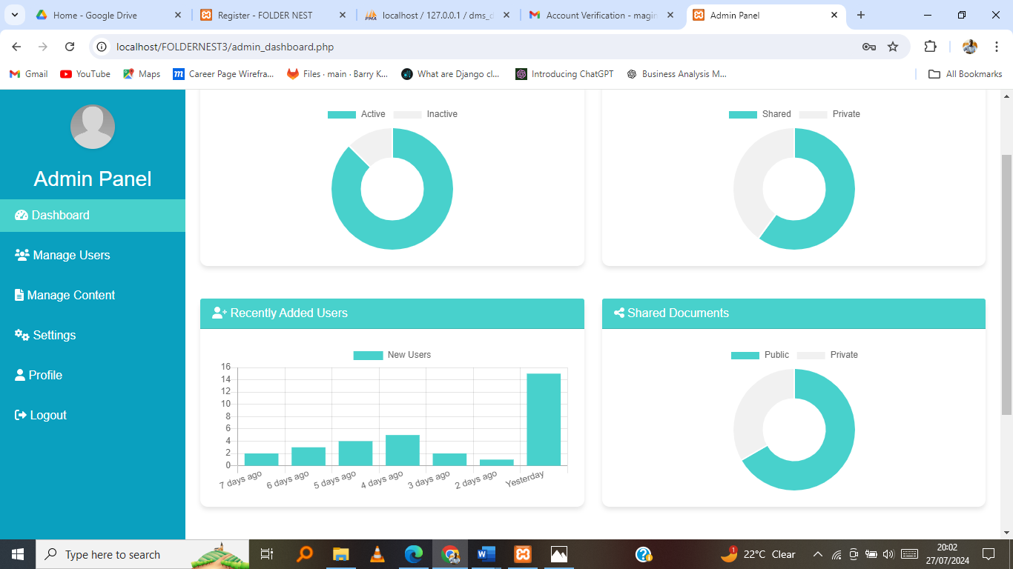

Admin manages Users

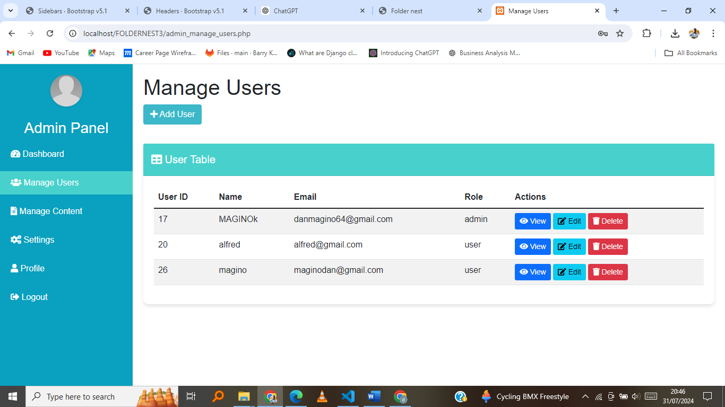

**Security and Efficiency**

Folder Nest places a strong emphasis on security. By using email-based authentication, the system ensures that access is restricted to verified users.

The system's user interface is designed to be user-friendly, allowing users to perform complex operations with ease. This reduces the learning curve.

**Conclusion**

Folder Nest is a comprehensive document management system that caters to the needs of both regular users and administrators. With its robust authentication mechanisms and comprehensive set of features, it provides a secure and efficient way to manage digital documents.